**OBSTACLE DETECTION USING ULTRASONIC SENSOR**

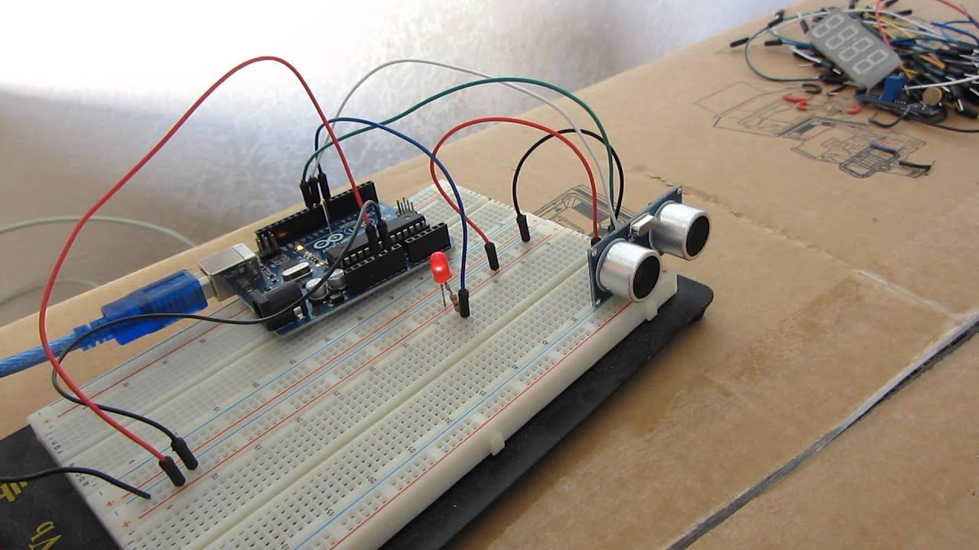

*By,*

*Mrinalini[RYLGRRD103]*

*Shiva[RYLGRRD101]*

*Shirisha[RYLGRRD102]*

**ABSTRACT:**

The **ultrasonic sensor** is used for **obstacle detection.**

**Ultrasonic sensor** transmits the ultrasonic waves from its sensor head and again receives the ultrasonic waves reflected from an object.

There are many applications use ultrasonic sensors like instruction alarm systems, automatic door openers, etc.

Basically, in many applications like vehicle control, medical applications, robotic movement control, etc; distance measurement of an object is used.

This can be done using a variety of sensors- Ultrasonic, IR, rader, laser, etc. Measurement using ultrasonic sensors is the cheapest and its reliability among several others is very high.

**INTRODUCTION:**

With the increasing demand for autonomous projects, the use of sensors is increasing.

Sensors are sophisticated devices that convert the physical parameter(for example: temperature, pressure, humidity, speed, etc.) into a signal which can be measured electrically.

They are very important to robotics.

It is able to give robots remote access and make decisions as for a desired environment.

It can also perceive its own environment and through programming can get the output it desires.

In industrial applications, ultrasonic sensors are characterised by their reliability and outstanding versatility.

Ultrasonic sensors can be used to solve even the most complex tasks involving object detection or level measurement with millimetre precision, because their measuring method works reliably under almost all conditions.

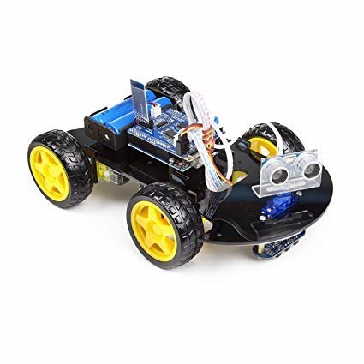

**CRITERIA TO CHOOSE A SENSOR:**

With the large number of sensors available in the market, it is necessary to choose a right sensor. There are certain features which have to be considered when we choose a sensor: Accuracy, Environmental condition, Range, Calibration, Resolution, Cost and Repeatability.

**Features of Ultrasonic sensor:**

*The device is extremely robust, making it suitable for even the toughest conditions.

*The sensor surface cleans itself through vibration, making the sensor insensitive to dirt.

*The physical principle- the propagation of sound- works, with a few exceptions, in practically any environment.

*Ultrasonic sensors have proven their reliability and endurance in virtually all industrial sectors.

**WORKING PRINCIPLE OF AN ULTRASONIC SENSOR:**

The ultrasonic sensor transmits sound waves and receives sound reflected from an object. When ultrasonic waves are incident on an object, diffused reflection of the energy takes place over a wide solid angle which might be as high as 180 degrees.

Thus, some fraction of the incident energy, is reflected back to the transducer in the form of echoes.

If the object is very close to the sensor, the sound waves returns quickly, but if the object is far away from the sensor, the signal takes so long to return.

The sensor uses the time it takes for the sound to come back from the object to front to determine the distance of the object.

The distance to the object(L) can then be calculated through the speed of ultrasonic waves (v) in the medium by the relation, where ‘t’ is the time taken by the wave to reach back to the sensor and tita is the angle between the horizontal and the path taken.

The ultrasonic sensor can measure distances in centimetres and inches. It can measure from 0 to 2.5 meters, with a precision of 3cm.

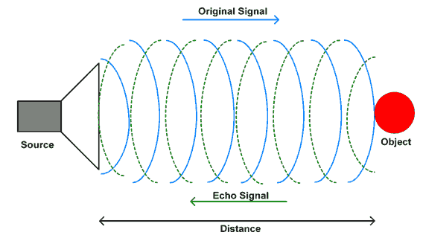

**HCSR04 range sensor:**

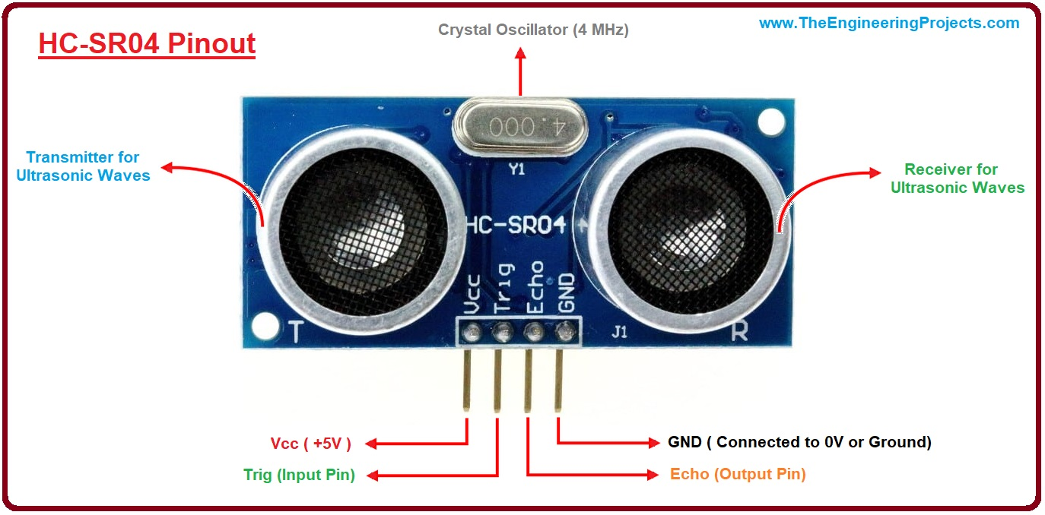

HC-SR04 is a commonly used module for non-contact distance measurement for distances from 2cm to 400cm.

It has 4 pins:

VCC- 5V, input power, TRIG- Trigger Input; ECHO- Echo Output; GND- Ground

A trigger signal is provided to TRIG input, a HIGH signal of at least 10 micro seconds duration. This enables the module to transmit eight 40KHz ultrasonic burst. If there is an obstacle in-front of the module, it will reflect those ultrasonic waves. If the signal comes back, the ECHO output of the module will be HIGH for duration of time taken for sending and receiving ultrasonic signals.

The pulse width ranges from 150 micro seconds to 25 milli seconds depending upon the distance of the obstacle from the sensor and it will be about 30 milli seconds if there is no obstacle.

**ARDUINO UNO:**

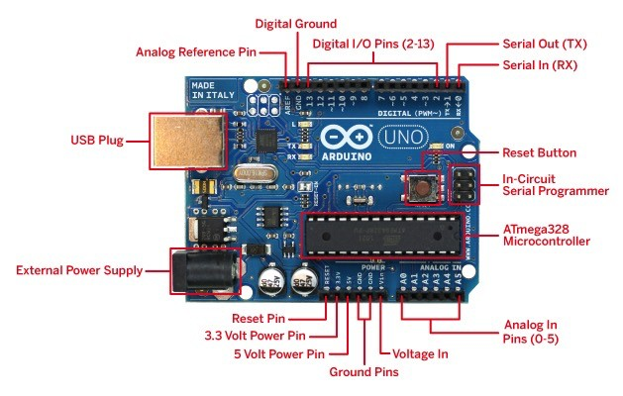

**Arduino UNO** is a microcontroller board based on the ATmega328P (datasheet).

It has 14 digital input/output pins (of which 6 can be used as PWM outputs), 6 analog inputs, a 16MHz quartz crystal, a USB connection, a power jack, an ICSP header and a reset button.

It contains everything needed to support the microcontroller; simply connect it to a computer with a USB cable or power it to a computer with a USB cable or power it with a AC-to-DC adapter or battery to get started.

“UNO” means one in Italian and was chosen to mark the release of Arduino Software(IDE) 1.0. The UNO board and version 1.0 of Arduino Software(IDE) were the reference versions of Arduino, now evolved to newer releases.

The UNO board is the first in a series of USB Arduino boards, and the reference model for the Arduino platform .

**COMPONENTS REQUIRED:**

|  |  |  |
| --- | --- | --- |
| S.no | Components | Quantity |
| 1 | Arduino UNO | 1 |
| 2 | Bread board | 1 |
| 3 | HC-SR04 ultrasonic sensor | 1 |
| 4 | LED | 1 |
| 5 | Male to Male connectors | 6 |

**PROCEDURE:**

1. Add the LED to the breadboard.

Connect the short leg of the LED to Ground, long leg of LED to pin 13 with male to male connector.

1. Add the ultrasonic sensor to the breadboard. There are 4 pins in the ultrasonic sensor. They are, VCC(5V power supply), TRIG(Trigger), ECHO, Gnd(Ground). Connect the VCC to 5V power supply, GND to ground, ECHO to pin 10, TRIG to pin 9 with male to male connectors.
2. Connect the Arduino UNO to the laptop and run the program.

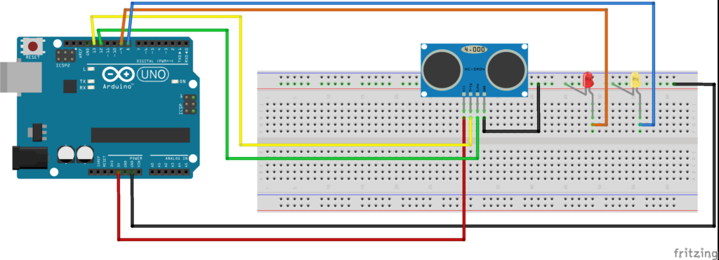

**PROGRAM:**

//defines pins numbers

const int trigPin=9;

const int echoPin=10;

const int buzzer=11;

const int ledPin=13;

//defines variables

long duration;

int distance;

int safetyDistance;

void setup()

{

pinMode(trigPin, OUTPUT); //sets the trigPin as an Output

pinMode(echoPin, INPUT); //Sets the echoPin as an Input

pinMode(buzzer, OUTPUT);

pinMode(ledPin, OUTPUT);

Serial.begin(9600); //Starts the serial communication

}

void loop() {

// clears the trigPin

digitalWrite(trigPin, LOW);

delayMicroseconds(2);

// Sets the trigPin on HIGH state for 10 micro seconds

digitalWrite(trigPin, HIGH);

delayMicroseconds(10);

digitalWrite(trigPin, LOW);

//Reads the echoPin, returns the sound wave travel time in microseconds

duration= pulsein(echoPin, HIGH);

//Calculating the distance

distance=duration*0.034/2;

safetyDistance=distance;

if (safetyDistance <=5) {

digitalWrite(buzzer, HIGH);

digitalWrite(ledPin, HIGH);

}

else{

digitalWrite(buzzer, LOW);

digitalWrite(buzzer, LOW);

}

}

**OBSERVATIONS:**

When we bring an obstacle closer to the ultrasonic sensor, we will see that the LED glows.

When we move the obstacle away, the LED turns off.

The LED follows two methods:

* digitalWrite(trigPin,HIGH)

which sends a HIGH signal to LED making it glow.

* digitalWrite(trigPin,LOW)

which sends a low signal to LED turning it off.

**CONCLUSION:**

The HCSR-04 ultrasonic sensor was selected.

It was used for the distance measurements of the obstacles that appear or lie in the path of the prototype.

On successful implementation of distance measurement, the obstacle detection algorithm was carried out with minimal errors, by coding the algorithm in java, C and C++.

Obstacle detection is a very good application to be used in vehicles, preventing many accidents and loss of life.